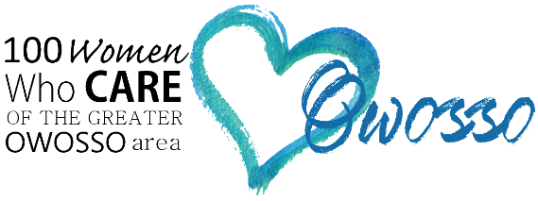2016 Commitment Form
Thank you so much for your interest in 100 Women Who Care of the Greater Owosso Area!
If you would like to join, please complete the commitment form and mail to Cindy Schluckebier. You may also email your form to owossowomencare@gmail.com. Please feel free to share this exciting opportunity with your family, friends, neighbors and co-workers!
(Please print clearly)
First Name: __________________________________ Last Name: _____________________________________
Address: _____________________________________________________________________________________
City: __________________________________ State: _______________________ Zip: ______________________
Phone: ____________________________________ Alternate Phone: ____________________________________
Email Address: ___________________________________ @______________________._____________
How did you hear about 100 Women Who Care in the Greater Owosso Area?
A Friend My Church Media Facebook Other
Please provide additional information (name of friend, church, etc.): _____________________________________
I understand that I am making a commitment to 100+ Women Who Care of the Greater Owosso Area to make an annual donation of $300 – ($100 at each of our three 2016 meetings) – given directly to local charities and non-profits serving the Greater Owosso Area. I understand that even if I did not vote for the charity chosen by the majority vote, I will fulfill my donation commitment. I also understand that if I am not able to attend the meeting that I will provide my check to another member to deliver or mail in advance of the meeting.
My commitment will automatically renew, for successive one year periods, unless notice is given.
Check one: □ I agree to have my contact information included in the 100 Women Who Care Membership Directory.
□ Do not include my contact information in the 100 Women Who Care Membership Directory.
______________________________________________ _______________________________________ Signature Date
Mail Commitment Form To: 2016 Meeting Dates
Cindy Schluckebier February 29, 2016
1471 W. Wilkinson Road May 16, 2016
Owosso, MI 48867 September 26, 2016
owossowomencare@gmail.com

